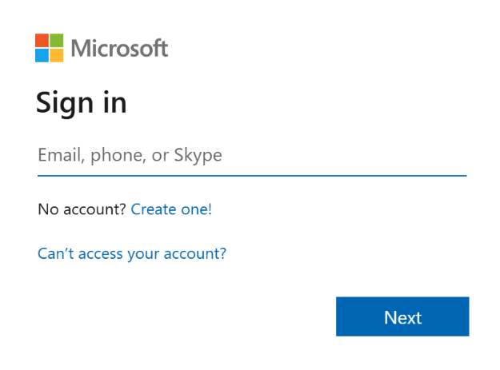
Students should sign into Microsoft.
Their email address is:
surname.firstname@s.parkhigh.apex-trust.org
Students should then type in their password.
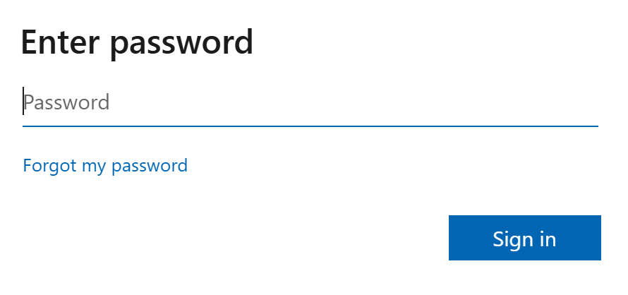

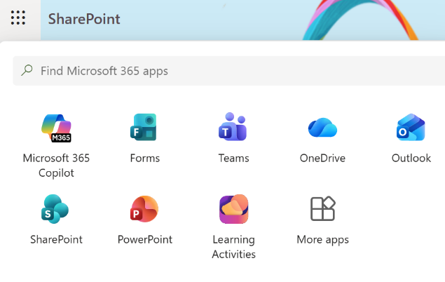
Students should click on to Sharepoint using the nine dots in the top left corner.

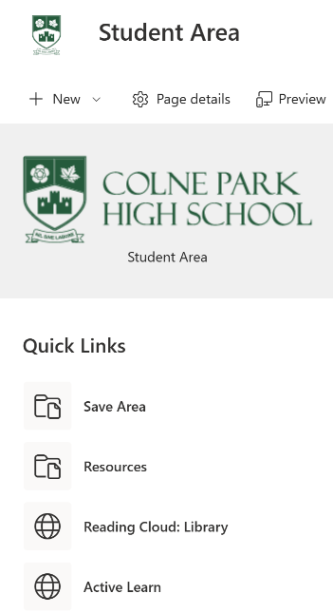
Students will then be in the Student Area. They
should click on the Resources link on the left.

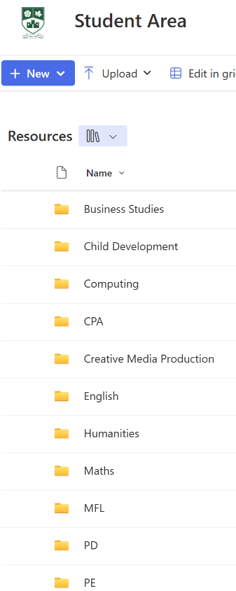
Once students are into the Resource Area they should
select the subject they wish to study from the list of folders.
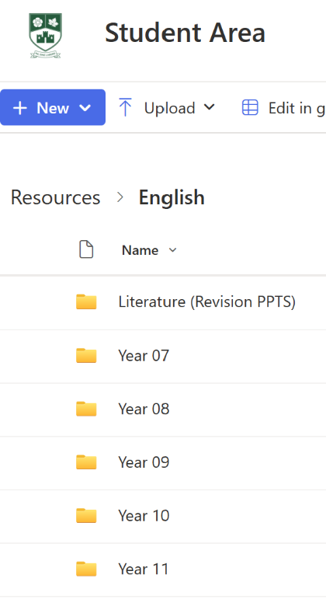

Students should then select their year group.

Students should then select the half term or term.
